**CANTHO UNIVERSITY**

**College of ICT - IT Department**

**WEEK 14 - EXERCISE**

* Course name: Oracle DBMS, CT208H
* CourseID: CT208H-M02
* Duration: 90 mins. (from 14h00 to 15h30)
* Store the answers to ExWeek14-studentID.sql. Upload this file to your folder of this class on GDrive.
* Contents:

**Question 1:** Create a database for Airline ticket management. Constraints (PK, FK, check, not null, and default) and regular expressions must be used.

**+ Airline information**

**+ Customer information**

**+ Booking information**

Input at least 2 rows for airline information table

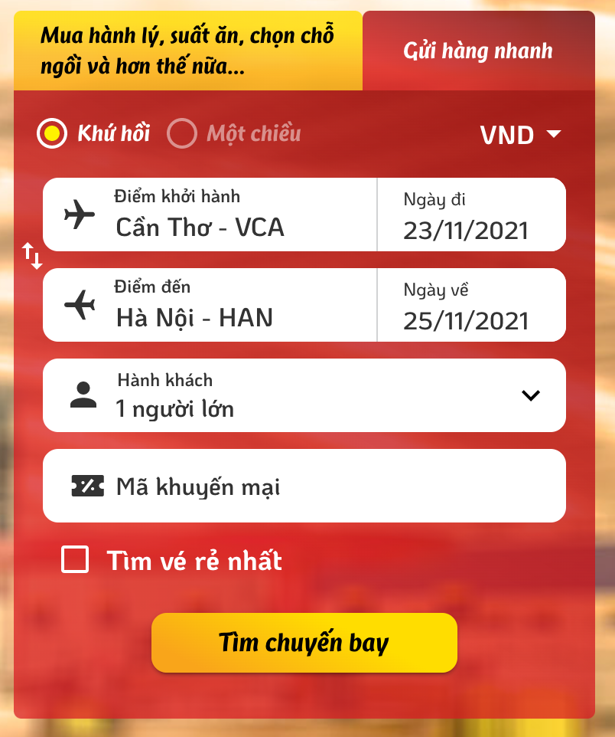

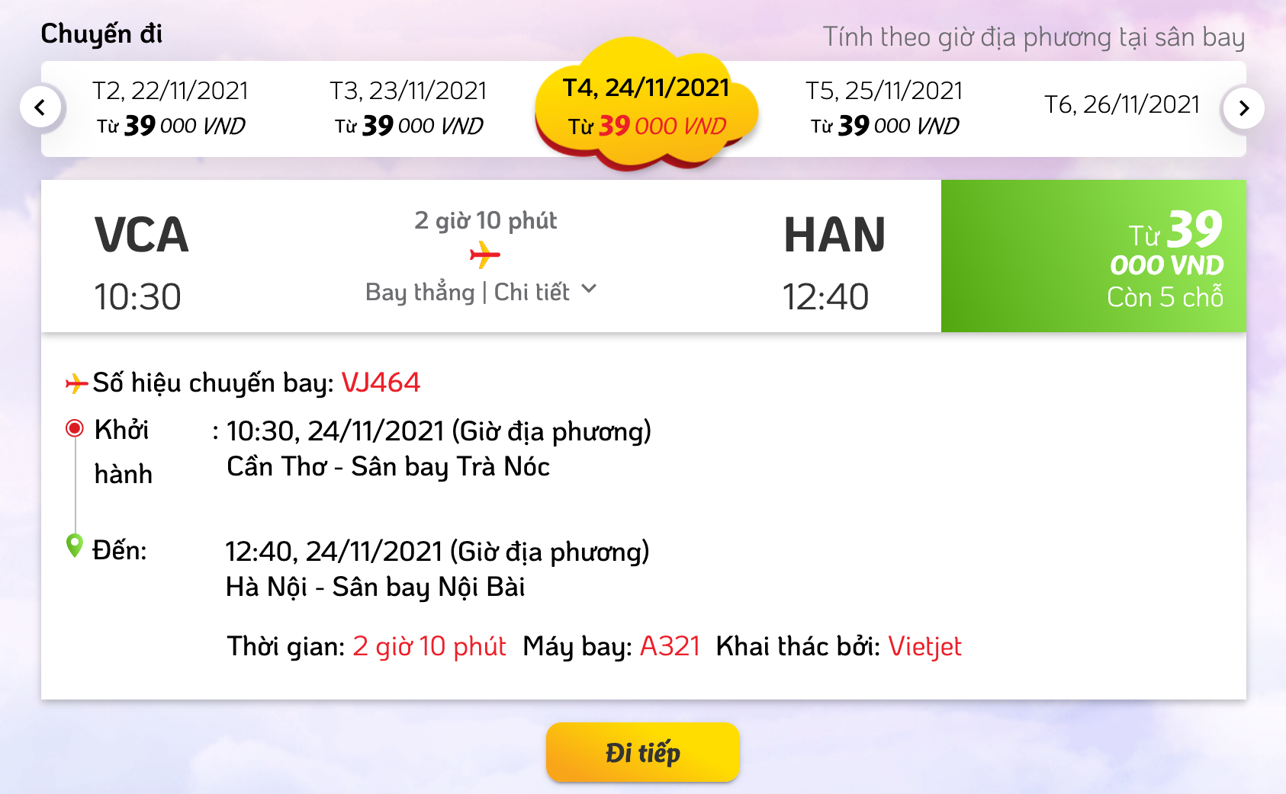

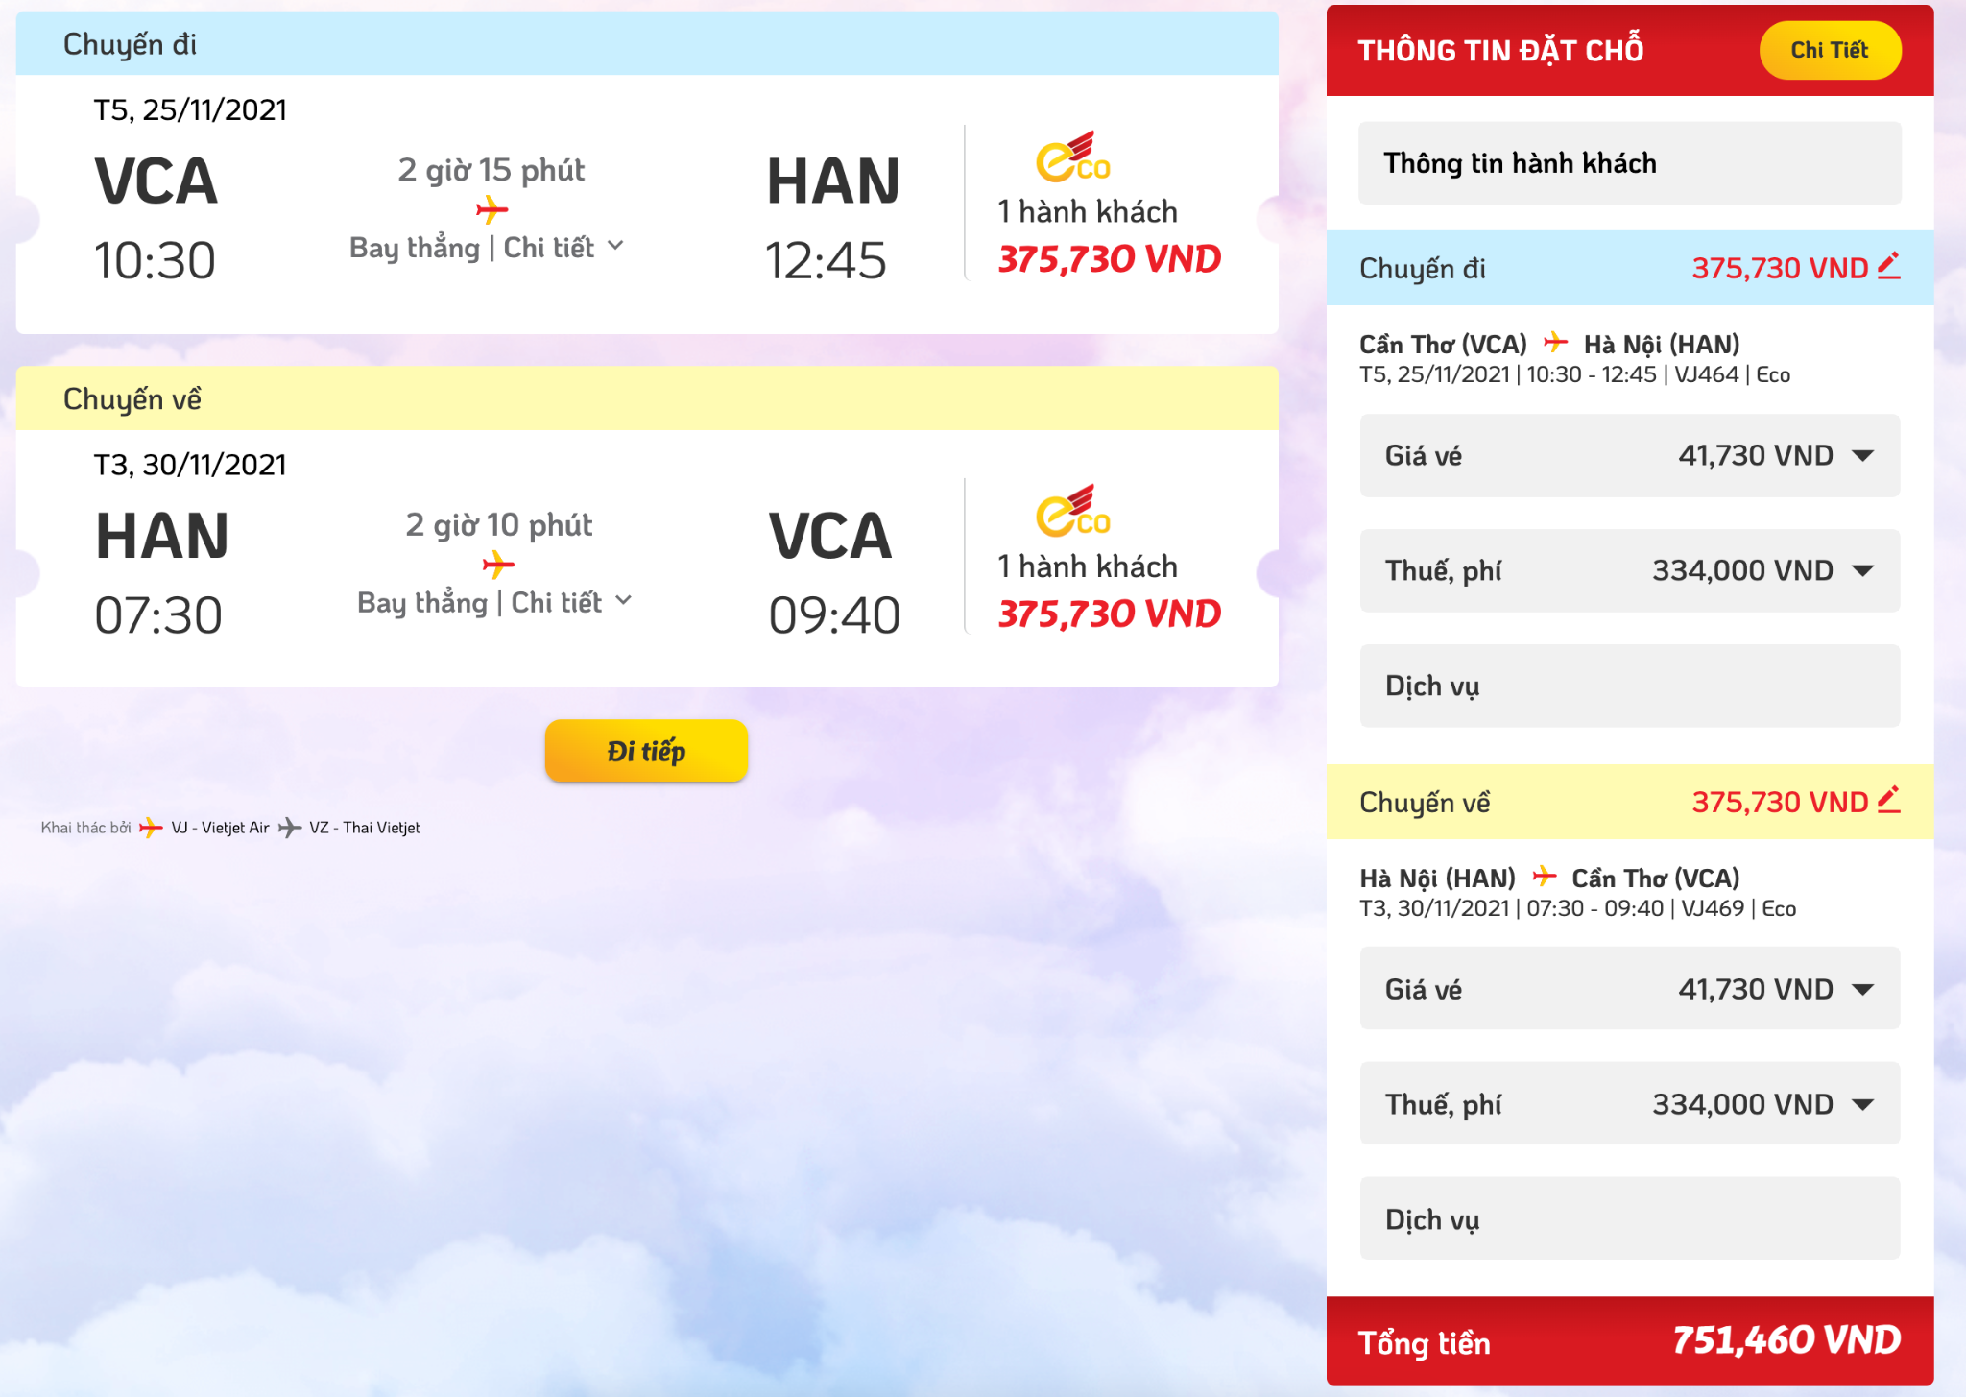

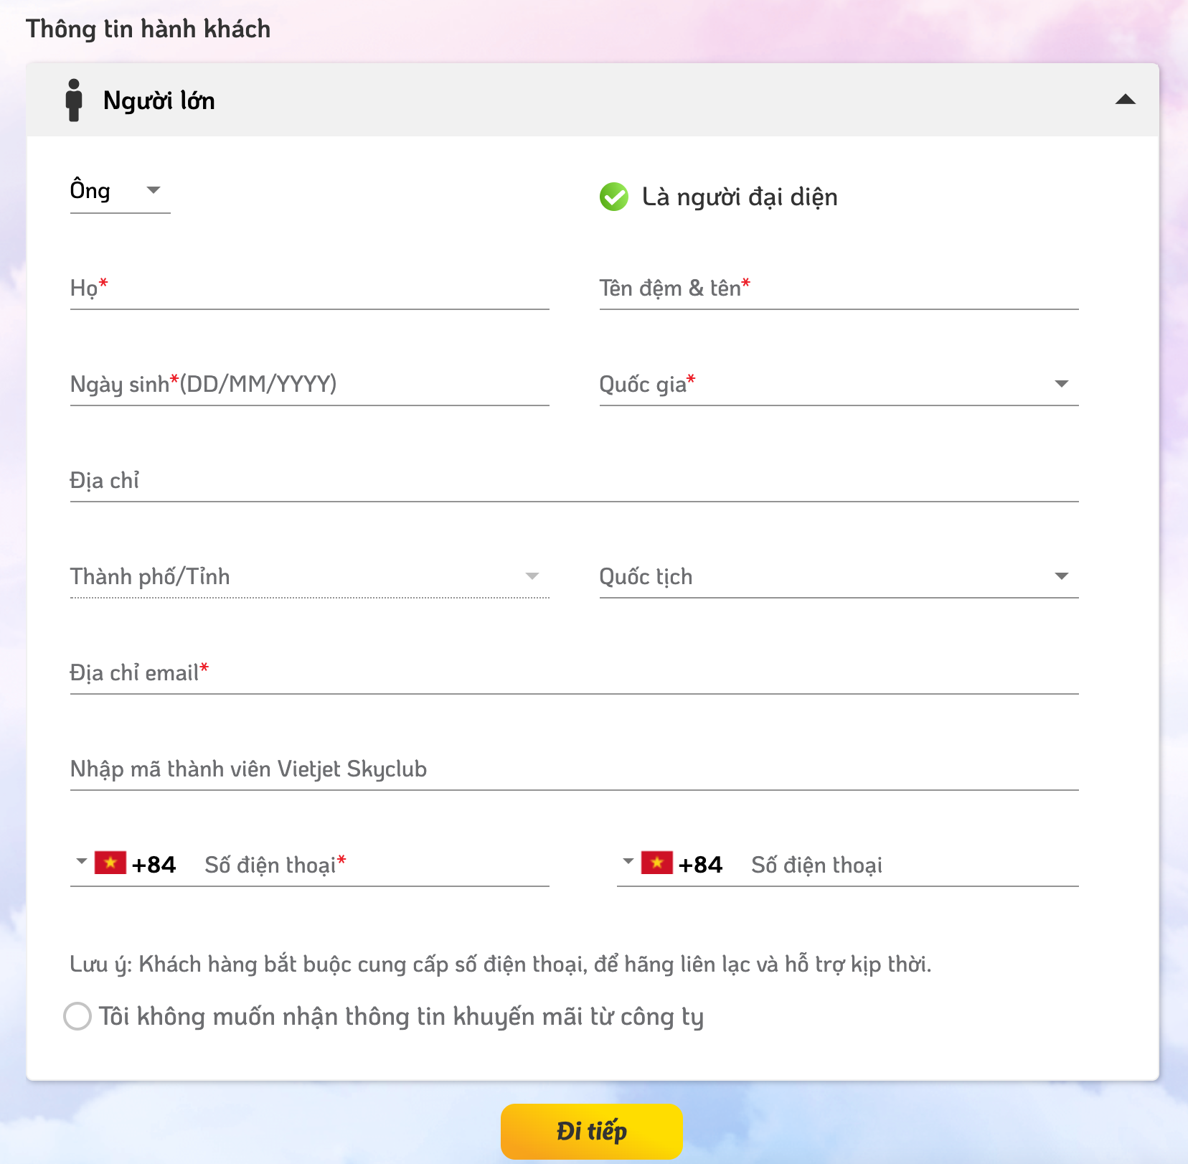

Please visit <https://www.vietjetair.com/vi> for getting more information.

**Question 2:** Create a procedure for booking a ticket by a customer. Test it.

**Question 3:** Create a function for searching airline information (input: start place, arrival place, start date, arrival date; return: airline information). Test it.